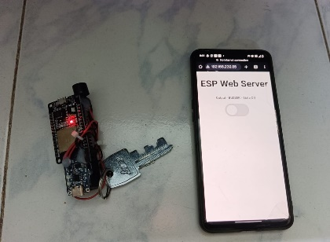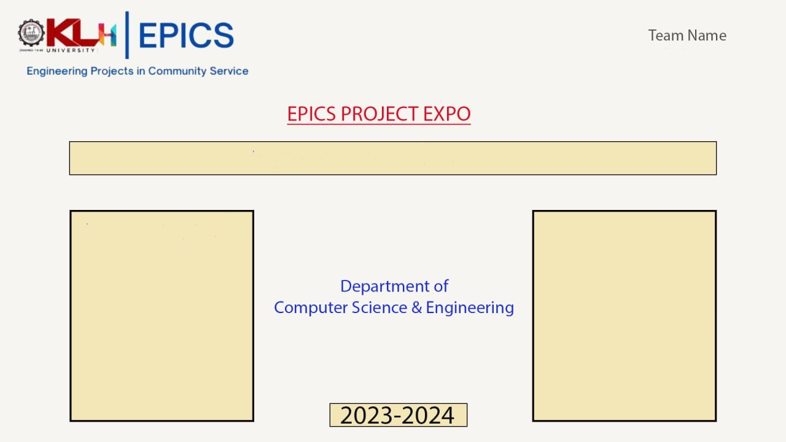

TECH ARMY

SMART KEYCHAIN FINDER

TEAM MEMBERS

Lalitha-2210030372

Trisha -2210030338

Tulasi-2210030388

Sumera-2210030505

Hema-2210030341

Anusha-2210030304